Пензенский государственный университет Кафедра «Вычислительная техника»

# ОТЧЕТ

по лабораторной работе №4

по дисциплине: "Арифметические и логические основы вычислительной техники" на тему: "Сложение/вычитание чисел в цифровых процессорах в формате с ФТ"

Выполнил:

студент группы 23ВВВ3 бригады 3:

Полиневский Вадим

Принял:

Калиниченко Е. И

Пенза, 2024

1. Представил числа **a** = 69 = 4516; **b** = - 84 =-5416; **-a =** -69 = -4516 и

**-b =**84 = 5416в дополнительном коде:

8-разрядный процессор:

[a]2 = 0100 0101

[b]2 = 1010 1100

[-a] = 1011 1011

[-b] = 0101 0100

16-разрядный процессор:

[a]2 = 0000 0000 0100 0101

[b]2 = 1111 1111 1010 1100

[-a]2 = 1111 1111 1011 1011

[-b]2 = 0000 0000 0101 0100

1. **Нашёл значение выражения a + b**

8-разрядный процессор:

|  |  |  |  |  |  |  |  |  |
| --- | --- | --- | --- | --- | --- | --- | --- | --- |
| [a]2  +  [b]2 | 0 | 1 | 0 | 0 | 0 | 1 | 0 | 1 |
| 1 | 0 | 1 | 0 | 1 | 1 | 0 | 0 |
| [y]2 | 1 | 1 | 1 | 1 | 0 | 0 | 0 | 1 |
| SF = 1 ; CF = 0 ; OF = 0; ZF = 0; | | | | | | | | |

Перевод результата:

[y]2 =[1111 0001]2 = [1000 1111]1 = -F16 = -1510

Проверка:

y = a + b = 6910 + (-8410) = -1510

16-разрядный процессор:

|  |  |  |  |  |  |  |  |  |  |  |  |  |  |  |  |  |
| --- | --- | --- | --- | --- | --- | --- | --- | --- | --- | --- | --- | --- | --- | --- | --- | --- |
| [a]2  +  [-b]2 | 0 | 0 | 0 | 0 | 0 | 0 | 0 | 0 | 0 | 1 | 0 | 0 | 0 | 1 | 0 | 1 |
| 1 | 1 | 1 | 1 | 1 | 1 | 1 | 1 | 1 | 0 | 1 | 0 | 1 | 1 | 0 | 0 |
| [y]2 | 1 | 1 | 1 | 1 | 1 | 1 | 1 | 1 | 1 | 1 | 1 | 1 | 0 | 0 | 0 | 1 |
| SF = 1 ; CF = 0 ; OF = 0; ZF = 0; | | | | | | | | | | | | | | | | |

Перевод результата:

[y]2 = [1111 1111 1111 0001]2 = [1000 0000 0000 1111]1 = -000F16 = -1510

Проверка: y = a + b = 6910 + (-8410) = -1510

1. Выполнил проверку:

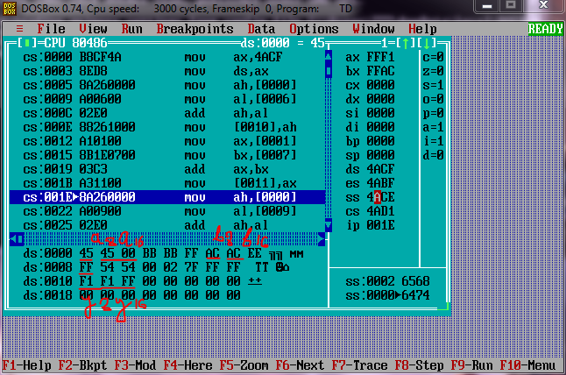

1. **Нашёл значение выражения y = a - b = a + (-b)**

8-разрядный процессор:

|  |  |  |  |  |  |  |  |  |
| --- | --- | --- | --- | --- | --- | --- | --- | --- |
| [a]2  +  [-b]2 | 0 | 1 | 0 | 0 | 0 | 1 | 0 | 1 |
| 0 | 1 | 0 | 1 | 0 | 1 | 0 | 0 |
| [y]2 | 1 | 0 | 0 | 1 | 1 | 0 | 0 | 1 |
| SF = 1 ; CF = 0 ; OF =1; ZF = 0; | | | | | | | | |

Произошло переполнение. OF = 1.

16-разрядный процессор:

|  |  |  |  |  |  |  |  |  |  |  |  |  |  |  |  |  |
| --- | --- | --- | --- | --- | --- | --- | --- | --- | --- | --- | --- | --- | --- | --- | --- | --- |
| [a]2  +  [-b]2 | 0 | 0 | 0 | 0 | 0 | 0 | 0 | 0 | 0 | 1 | 0 | 0 | 0 | 1 | 0 | 1 |
| 0 | 0 | 0 | 0 | 0 | 0 | 0 | 0 | 0 | 1 | 0 | 1 | 0 | 1 | 0 | 0 |
| [y]2 | 0 | 0 | 0 | 0 | 0 | 0 | 0 | 0 | 1 | 0 | 0 | 1 | 1 | 0 | 0 | 1 |
| SF = 0; CF = 0 ; OF = 0; ZF = 0; | | | | | | | | | | | | | | | | |

Перевод результата:

[y]2 = [0000 0000 1001 1001]2 = [0000 0000 1001 1001]1 = 15310

y = a + (-b) = 4516  + (-(-54))16 = 9916 = 15310

1. Выполнил проверку:

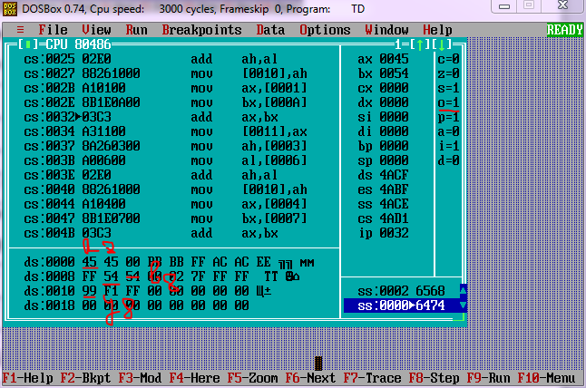

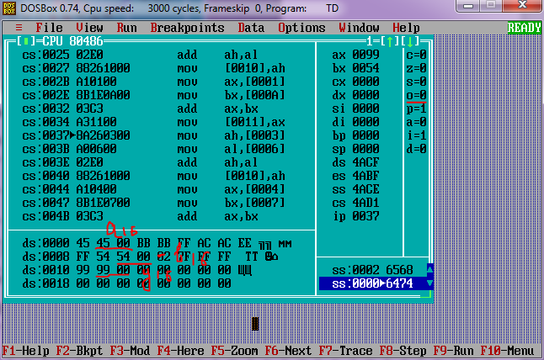

1. **Нашёл значение выражения y = - a + b**

8-разрядный процессор:

|  |  |  |  |  |  |  |  |  |
| --- | --- | --- | --- | --- | --- | --- | --- | --- |
| [-a]2  +  [b]2 | 1 | 0 | 1 | 1 | 1 | 0 | 1 | 1 |
| 1 | 0 | 1 | 0 | 1 | 1 | 0 | 0 |
| [y]2 | 1 | 1 | 1 | 0 | 0 | 1 | 1 | 1 |
| SF = 1 ; CF = 1 ; OF =1; ZF = 0; | | | | | | | | |

Произошло переполнение. OF = 1;

16-разрядный процессор:

|  |  |  |  |  |  |  |  |  |  |  |  |  |  |  |  |  |
| --- | --- | --- | --- | --- | --- | --- | --- | --- | --- | --- | --- | --- | --- | --- | --- | --- |
| [-a]2  +  [b]2 | 1 | 1 | 1 | 1 | 1 | 1 | 1 | 1 | 1 | 0 | 1 | 1 | 1 | 0 | 1 | 1 |
| 1 | 1 | 1 | 1 | 1 | 1 | 1 | 1 | 1 | 0 | 1 | 0 | 1 | 1 | 0 | 0 |
| [y]2 | 1 | 1 | 1 | 1 | 1 | 1 | 1 | 1 | 0 | 1 | 1 | 0 | 0 | 1 | 1 | 1 |
| SF = 1 ; CF = 1 ; OF = 0; ZF = 0; | | | | | | | | | | | | | | | | |

Перевод результата:

[y]2 = [1111 1111 0110 0111] = [1000 0000 1001 1001] = -009916 = -15310

y = - 69 + (-84) = -15310

Проверка:

y = - a + b = -69 + (-84) = -153

1. Выполнил проверку:

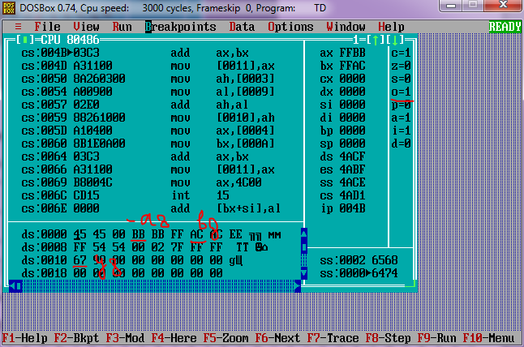

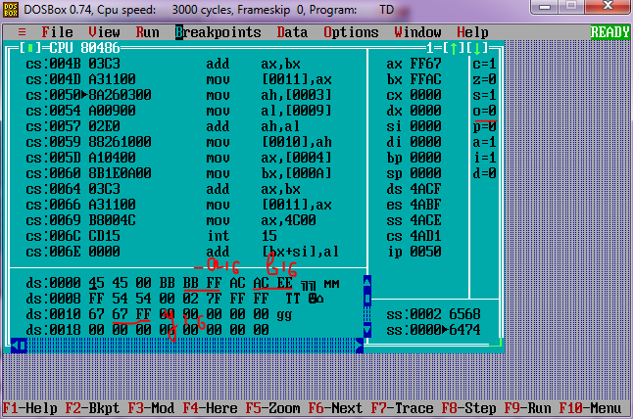

1. **Нашёл значение выражения y = - a - b = -a + (-b)**
2. разрядный процессор:

|  |  |  |  |  |  |  |  |  |
| --- | --- | --- | --- | --- | --- | --- | --- | --- |
| [-a]2  +  [-b]2 | 1 | 0 | 1 | 1 | 1 | 0 | 1 | 1 |
| 0 | 1 | 0 | 1 | 0 | 1 | 0 | 0 |
| [y]2 | 0 | 0 | 0 | 0 | 1 | 1 | 1 | 1 |
| SF = 0 ; CF = 1; OF =0 ; ZF = 0; | | | | | | | | |

Перевод результата:

[y]2 = [0000 1111]2 = [0000 1111]1 = F16 = 1510

y = -a - b = -6910 - (-(8410)) = 1510

16-разрядный процессор:

|  |  |  |  |  |  |  |  |  |  |  |  |  |  |  |  |  |
| --- | --- | --- | --- | --- | --- | --- | --- | --- | --- | --- | --- | --- | --- | --- | --- | --- |
| [-a]2  +  [-b]2 | 1 | 1 | 1 | 1 | 1 | 1 | 1 | 1 | 1 | 0 | 1 | 1 | 1 | 0 | 1 | 1 |
| 0 | 0 | 0 | 0 | 0 | 0 | 0 | 0 | 0 | 1 | 0 | 1 | 0 | 1 | 0 | 0 |
| [y]2 | 0 | 0 | 0 | 0 | 0 | 0 | 0 | 0 | 0 | 0 | 0 | 0 | 1 | 1 | 1 | 1 |
| SF = 0 ; CF = 1 ; OF = 0; ZF = 0; | | | | | | | | | | | | | | | | |

[y]2 = [0000 1111]2 = [0000 1111]1 = F16 = 1510

y = -a - b = -6910 - (-(8410)) = 1510

1. Выполнил проверку:

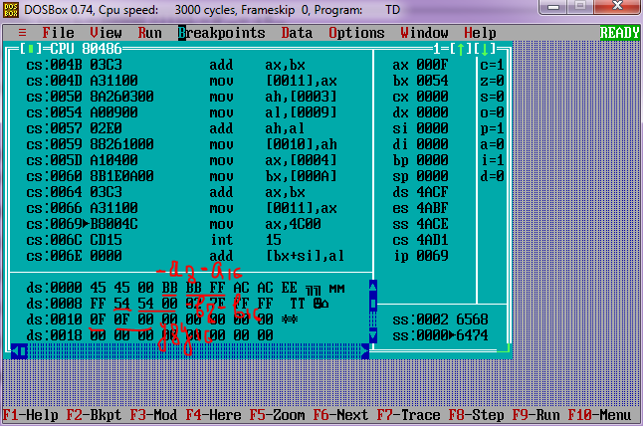

1. Представил числа c = 0,69 = B0A3; d = -0,8410 = -0,D70A ; -c= -0,6910= -B0A3; -c = 0,84 = 0,D70A; в дополнительном коде:

8-разрядный процессор:

[c]2 = 0101 1000

[d]2 = 1001 0100

[-c]2 =1010 1000

[-d]2 = 0110 1011

16-разрядный процессор:

[c]2 = 0101 1000 0101 0001

[d]2 = 1001 0100 0111 1011

[-c]2 = 1010 0111 1010 1111

[-d]2 =0110 1011 1000 0101

1. **Нашёл значения выражения y = с + d**

8-разрядный процессор:

|  |  |  |  |  |  |  |  |  |
| --- | --- | --- | --- | --- | --- | --- | --- | --- |
| [с]2  +  [d]2 | 0 | 1 | 0 | 1 | 1 | 0 | 0 | 0 |
| 1 | 0 | 0 | 1 | 0 | 1 | 0 | 0 |
| [y]2 | 1 | 1 | 1 | 0 | 1 | 1 | 0 | 0 |
| SF = 1 ; CF = 0; OF =0 ; ZF = 0; | | | | | | | | |

Перевод результата:

[y]2 = [1110 1100]2 = [1001 0100]1= -0, 0010 10002 = 0, 2816 =0,15610

Y10 = 0,69 +(-0,842) = 0.15

16-разрядный процессор:

|  |  |  |  |  |  |  |  |  |  |  |  |  |  |  |  |  |
| --- | --- | --- | --- | --- | --- | --- | --- | --- | --- | --- | --- | --- | --- | --- | --- | --- |
| [c]2  +  [d]2 | 0 | 1 | 0 | 1 | 1 | 0 | 0 | 0 | 0 | 1 | 0 | 1 | 0 | 0 | 0 | 1 |
| 1 | 0 | 0 | 1 | 0 | 1 | 0 | 0 | 0 | 1 | 1 | 1 | 1 | 0 | 1 | 1 |
| [y]2 | 1 | 1 | 1 | 0 | 1 | 1 | 0 | 0 | 1 | 1 | 0 | 0 | 1 | 1 | 0 | 0 |
| SF = 1 ; CF = 0 ; OF = 0; ZF = 0; | | | | | | | | | | | | | | | | |

Перевод результата:

[y]2 = [1110 1100 1100 1100]2 = [1001 0011 0011 0100]1= -0, 0010 0110 0110 10002 = 0.266816 =0.1500210

y = 0,692 +(-0,842) = 0.15

1. Выполнил проверку:

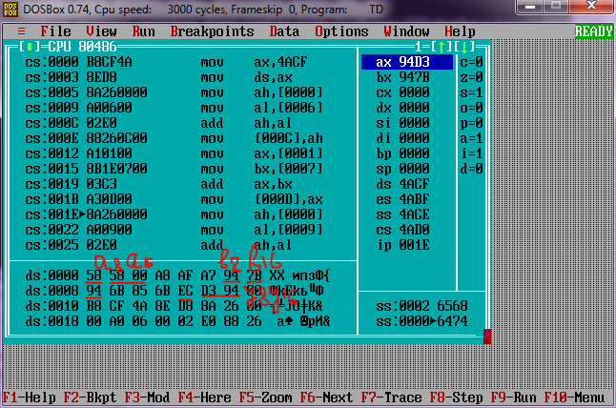

1. **Нашёл значение выражения y = c - d = с + (-d)**

8-разрядный процессор:

|  |  |  |  |  |  |  |  |  |
| --- | --- | --- | --- | --- | --- | --- | --- | --- |
| [с]2  +  [-d]2 | 0 | 1 | 0 | 1 | 1 | 0 | 0 | 0 |
| 0 | 1 | 1 | 0 | 1 | 0 | 1 | 1 |
| [y]2 | 1 | 1 | 0 | 0 | 0 | 0 | 1 | 1 |
| SF = 1 ; CF = 1; OF =1; ZF = 0; | | | | | | | | |

Переполнение. Результат сложения: OF = 1;

16-разрядный процессор:

|  |  |  |  |  |  |  |  |  |  |  |  |  |  |  |  |  |
| --- | --- | --- | --- | --- | --- | --- | --- | --- | --- | --- | --- | --- | --- | --- | --- | --- |
| [c]2  +  [-d]2 | 0 | 1 | 0 | 1 | 1 | 0 | 0 | 0 | 0 | 1 | 0 | 1 | 0 | 0 | 0 | 1 |
| 0 | 1 | 1 | 0 | 1 | 0 | 1 | 1 | 1 | 0 | 0 | 0 | 0 | 1 | 0 | 1 |
| [y]2 | 1 | 1 | 1 | 0 | 1 | 1 | 0 | 0 | 1 | 1 | 0 | 0 | 1 | 1 | 0 | 0 |
| SF = 1 ; CF = 1 ; OF = 1; ZF = 0; | | | | | | | | | | | | | | | | |

Переполнение. Результат сложения: OF = 1;

1. Выполнил проверку:

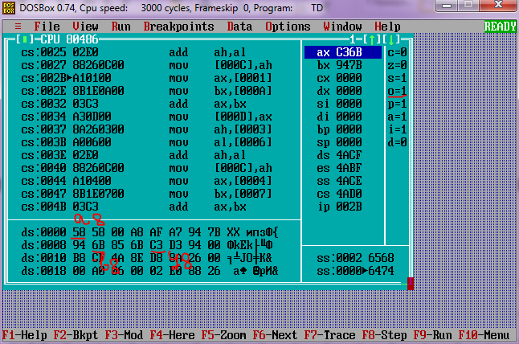

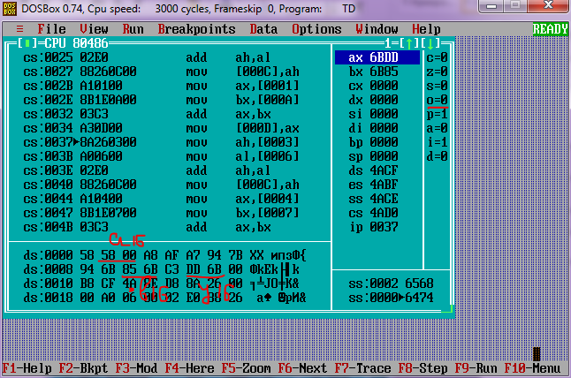

1. **Нашёл значение выражения y = - c + d**

8-разрядный процессор:

|  |  |  |  |  |  |  |  |  |
| --- | --- | --- | --- | --- | --- | --- | --- | --- |
| [-с]2  +  [d]2 | 1 | 0 | 1 | 0 | 1 | 0 | 0 | 0 |
| 1 | 0 | 0 | 1 | 0 | 1 | 0 | 0 |
| [y]2 | 0 | 0 | 1 | 1 | 1 | 1 | 0 | 0 |
| SF = 1 ; CF = 1; OF =1; ZF = 0; | | | | | | | | |

Переполнение. Результат сложения: OF = 1;

[y]2 = [1110 1100]2 = [1001 0100]1= -0, 0010 10002 = 0, 28 =0,15610

y = 0,692 +(-0,842) = 0.15

16-разрядный процессор:

|  |  |  |  |  |  |  |  |  |  |  |  |  |  |  |  |  |
| --- | --- | --- | --- | --- | --- | --- | --- | --- | --- | --- | --- | --- | --- | --- | --- | --- |
| [-c]2  +  [d]2 | 1 | 0 | 1 | 0 | 0 | 1 | 1 | 1 | 1 | 0 | 1 | 0 | 1 | 1 | 1 | 1 |
| 1 | 0 | 0 | 1 | 0 | 1 | 0 | 0 | 0 | 1 | 1 | 1 | 1 | 0 | 1 | 1 |
| [y]2 | 0 | 0 | 1 | 1 | 1 | 1 | 0 | 0 | 0 | 0 | 1 | 0 | 0 | 1 | 1 | 1 |
| SF = 0 ; CF = 1 ; OF = 1; ZF = 0; | | | | | | | | | | | | | | | | |

Переполнение. Результат сложения: OF = 1;

1. Выполнил проверку:

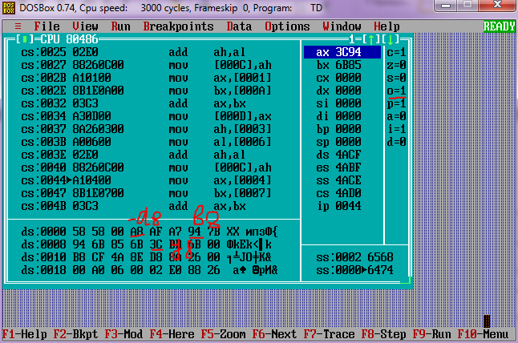

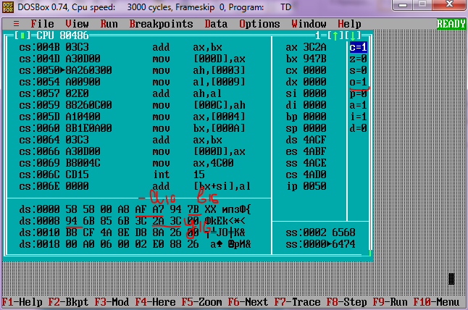

1. **Нашёл значение выражения y = -c - d = -c + (-d)**

8-разрядный процессор:

|  |  |  |  |  |  |  |  |  |
| --- | --- | --- | --- | --- | --- | --- | --- | --- |
| [-с]2  +  [-d]2 | 1 | 0 | 1 | 0 | 1 | 0 | 0 | 0 |
| 0 | 1 | 1 | 0 | 1 | 0 | 1 | 1 |
| [y]2 | 0 | 0 | 0 | 1 | 0 | 0 | 1 | 1 |
| SF = 0 ; CF = 1; OF = 0; ZF = 0; | | | | | | | | |

Перевод результата:

[y]2 = [0001 0011]2 = [0001 0011]1= 0, 001001102 = 0.26 = 0,14810

y = -0,692 + (-(-0,842)) = 0.15

16-разрядный процессор:

|  |  |  |  |  |  |  |  |  |  |  |  |  |  |  |  |  |
| --- | --- | --- | --- | --- | --- | --- | --- | --- | --- | --- | --- | --- | --- | --- | --- | --- |
| [-c]2  +  [-d]2 | 1 | 0 | 1 | 0 | 0 | 1 | 1 | 1 | 1 | 0 | 1 | 0 | 1 | 1 | 1 | 1 |
| 0 | 1 | 1 | 0 | 1 | 0 | 1 | 1 | 1 | 0 | 0 | 0 | 0 | 1 | 0 | 1 |
| [y]2 | 0 | 0 | 0 | 1 | 0 | 0 | 1 | 1 | 0 | 0 | 1 | 1 | 0 | 1 | 0 | 0 |
| SF = 0 ; CF = 1 ; OF = 0; ZF = 0; | | | | | | | | | | | | | | | | |

Перевод результата:

[y]2 = [0001 0011 0011 0100]2 = [0001 0011 0011 0100]1= 0, 00100110 0110 10002 = 0.26 = 0.1500216

y = -0,692 + (-(-0,842)) = 0.15

1. Выполнил проверку:

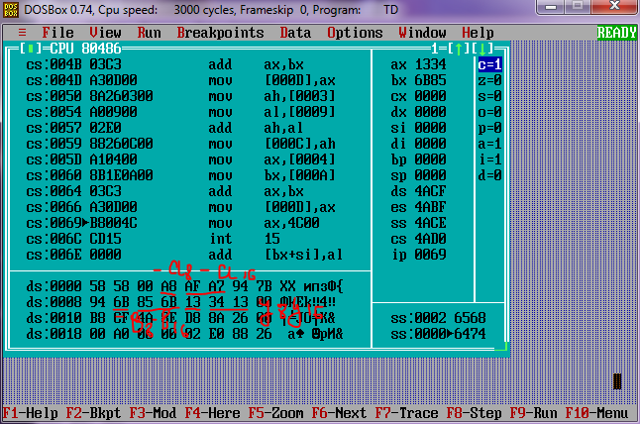

1. Представил числа f = 69,84 = 45,D7; g = -84,69 = -54, B0; -f = - 45,D7; -g = 54, B0; в дополнительном коде:

16-разрядный процессор:

[f]2 = 0100 0101, 0110 1011

[g]2 = 1010 1100, 1010 1000

[-f]2 = 1011 1011, 1001 0101

[-g]2= 0101 0011, 0101 1000

1. **Нашёл значение выражения: y = f + g**

16-разрядный процессор:

|  |  |  |  |  |  |  |  |  |  |  |  |  |  |  |  |  |
| --- | --- | --- | --- | --- | --- | --- | --- | --- | --- | --- | --- | --- | --- | --- | --- | --- |
| [f]2  +  [g]2 | 0 | 1 | 0 | 0 | 0 | 1 | 0 | 1 | 0 | 1 | 1 | 0 | 1 | 0 | 1 | 1 |
| 1 | 0 | 1 | 0 | 1 | 1 | 0 | 0 | 1 | 0 | 1 | 0 | 1 | 0 | 0 | 0 |
| [y]2 | 1 | 1 | 1 | 1 | 0 | 0 | 1 | 0 | 0 | 0 | 0 | 1 | 0 | 0 | 1 | 1 |
| SF = 1 ; CF = 0 ; OF = 0; ZF = 0; | | | | | | | | | | | | | | | | |

Перевод результата:

[y]2 =[1111 0010 0001 0000]2 = [1000 1101 1111 0000]1 = 1000 1110, 1110 1101 = -14, 851

y = 69,8410 + (-84,69)10 = -14,8510

1. Выполнил проверку:

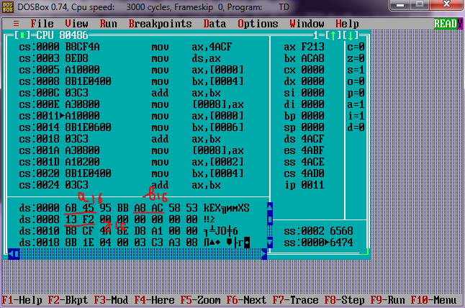

1. **Нашел значение: y = f - g = f + (-g)**

16-разрядный процессор:

|  |  |  |  |  |  |  |  |  |  |  |  |  |  |  |  |  |
| --- | --- | --- | --- | --- | --- | --- | --- | --- | --- | --- | --- | --- | --- | --- | --- | --- |
| [f]2  +  [-g]2 | 0 | 1 | 0 | 0 | 0 | 1 | 0 | 1 | 0 | 1 | 1 | 0 | 1 | 0 | 1 | 1 |
| 0 | 1 | 0 | 1 | 0 | 0 | 1 | 1 | 0 | 1 | 0 | 1 | 1 | 0 | 0 | 0 |
| [y]2 | 1 | 0 | 0 | 1 | 1 | 0 | 0 | 0 | 1 | 1 | 0 | 0 | 0 | 0 | 1 | 1 |
| SF = 0 ; CF = 1 ; OF = 0; ZF = 0; | | | | | | | | | | | | | | | | |

Переполнение. Результат сложения: OF = 1

1. Выполнил проверку:

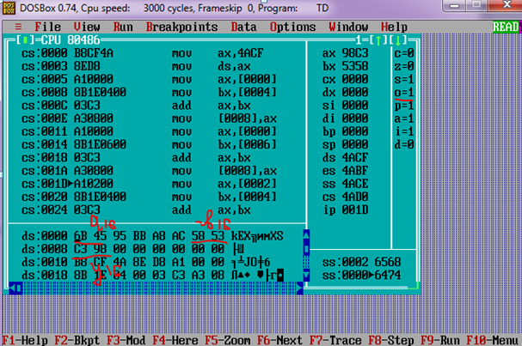

1. **Нашёл значение: y = -f + g**

16-разрядный процессор:

|  |  |  |  |  |  |  |  |  |  |  |  |  |  |  |  |  |
| --- | --- | --- | --- | --- | --- | --- | --- | --- | --- | --- | --- | --- | --- | --- | --- | --- |
| [-f]2  +  [g]2 | 1 | 0 | 1 | 1 | 1 | 0 | 1 | 0 | 1 | 0 | 0 | 1 | 0 | 1 | 0 | 1 |
| 1 | 0 | 1 | 0 | 1 | 1 | 0 | 0 | 1 | 0 | 1 | 0 | 1 | 0 | 0 | 0 |
| [y]2 | 0 | 0 | 0 | 1 | 0 | 1 | 1 | 1 | 0 | 0 | 1 | 1 | 1 | 1 | 1 | 0 |
| SF = 0 ; CF = 1 ; OF = 1; ZF = 0; | | | | | | | | | | | | | | | | |

Переполнение. Результат сложения: OF = 1;

1. Выполнил проверку:

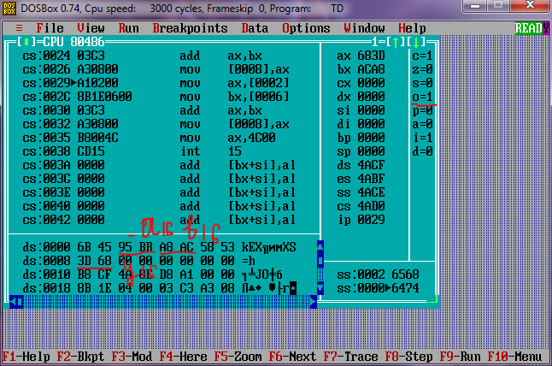

1. **Нашёл значение: y = -f - g = -f + (-g)**

|  |  |  |  |  |  |  |  |  |  |  |  |  |  |  |  |  |
| --- | --- | --- | --- | --- | --- | --- | --- | --- | --- | --- | --- | --- | --- | --- | --- | --- |
| [-f]2  +  [-g]2 | 1 | 0 | 1 | 1 | 1 | 0 | 1 | 1 | 1 | 0 | 0 | 1 | 0 | 1 | 0 | 1 |
| 0 | 1 | 0 | 1 | 0 | 0 | 1 | 1 | 0 | 1 | 0 | 1 | 1 | 0 | 0 | 0 |
| [y]2 | 0 | 0 | 0 | 0 | 1 | 1 | 1 | 0 | 1 | 1 | 1 | 0 | 1 | 1 | 0 | 1 |
| SF = 0 ; CF = 1 ; OF = 0; ZF = 0; | | | | | | | | | | | | | | | | |

[y]2 =[0000 1110 1110 1110]2 = [0000 1110 1110 1101]1 = 0000 1110, 1101 1010 = 14, 851

y = -69,8410 +(-(-84,69))10 = 14,8510

1. Выполнил проверку:

